ASSIGNMENT REPORT
Lab Report: Assignment 4 – JavaScript Alerts and Confirms
Tier 2: Advanced User Interactions
Field | Details
Tier | Tier 2: Advanced User Interactions
Module | Assignment 4 – Handling Overlays & JavaScript Dialogs
Framework | Selenium WebDriver with Python
Target URL | https://testautomationpractice.blogspot.com/

1. Objectives
- Automate native browser dialogs (Alerts, Confirmations, and Prompts) using Selenium WebDriver's switch_to.alert interface.
- Validate handling of JavaScript Simple Alert by accepting the dialog.
- Validate handling of Confirmation Box by explicitly calling .dismiss() (Cancel).
- Validate text injection into JavaScript Prompt Box using .send_keys() prior to submission.

2. Technical Task Execution Summary
Task | Target Dialog | Selenium Alert Method Used | Verification Action
Task 1 | Simple Alert | driver.switch_to.alert.accept() | Clicked 'Simple Alert' button, read alert text, clicked OK.
Task 2 | Confirm Box | driver.switch_to.alert.dismiss() | Clicked 'Confirmation Alert' button, read message, clicked Cancel.
Task 3 | Prompt Box | driver.switch_to.alert.send_keys("Riya Maiti") followed by .accept() | Clicked 'Prompt Alert', typed input text into prompt field, clicked OK.

3. Source Code & Screenshots
The automation script (assignment_4_alerts.py) consists of a setup block followed by three tasks. Each task is followed by the screenshot it captures during execution.

3.1 Setup & Scroll to Alerts Section
import time
from selenium import webdriver
from selenium.webdriver.common.by import By
from selenium.webdriver.support.ui import WebDriverWait
from selenium.webdriver.support import expected_conditions as EC

# 1. Initialize Driver
driver = webdriver.Chrome()
driver.get("https://testautomationpractice.blogspot.com/")
driver.maximize_window()
wait = WebDriverWait(driver, 10)

# Scroll to Alerts section
alert_section = driver.find_element(By.XPATH, "//button[text()='Simple Alert']")
driver.execute_script("arguments[0].scrollIntoView({behavior: 'smooth', block: 'center'});", alert_section)
time.sleep(1)

3.2 Task 1 – Simple JavaScript Alert (Accept)
# =============================================================
# TASK 1: SIMPLE JAVASCRIPT ALERT (ACCEPT)
# =============================================================
simple_alert_btn = driver.find_element(By.XPATH, "//button[text()='Simple Alert']")
simple_alert_btn.click()
time.sleep(1)

# Switch to Simple Alert and Accept
alert = wait.until(EC.alert_is_present())
print("Simple Alert Text:", alert.text)
alert.accept()
print("Task 1 Completed: Simple Alert accepted.")

driver.save_screenshot("assignment_4_step1_simple_alert.png")
print("Saved: assignment_4_step1_simple_alert.png")
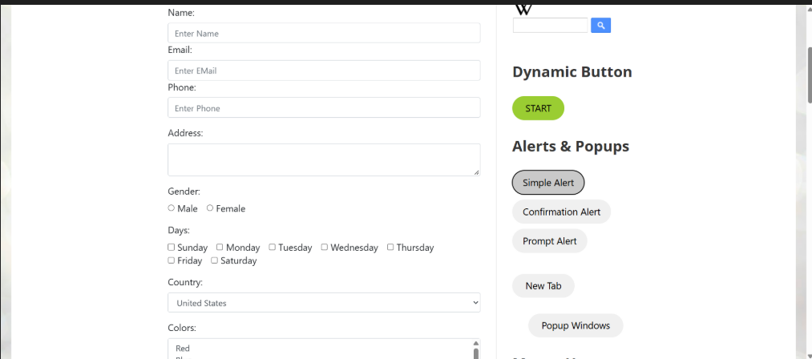
[ Insert Screenshot 1 here ]
assignment_4_step1_simple_alert.png
Figure 1: State after accepting the Simple Alert

3.3 Task 2 – Confirm Box (Dismiss)
# =============================================================
# TASK 2: CONFIRM BOX (DISMISS)
# =============================================================
confirm_btn = driver.find_element(By.XPATH, "//button[text()='Confirmation Alert']")
confirm_btn.click()
time.sleep(1)

# Switch to Confirm Box and Dismiss (Click Cancel)
confirm_alert = wait.until(EC.alert_is_present())
print("Confirm Box Text:", confirm_alert.text)
confirm_alert.dismiss()
print("Task 2 Completed: Confirm Box dismissed.")

driver.save_screenshot("assignment_4_step2_confirm_box.png")
print("Saved: assignment_4_step2_confirm_box.png")

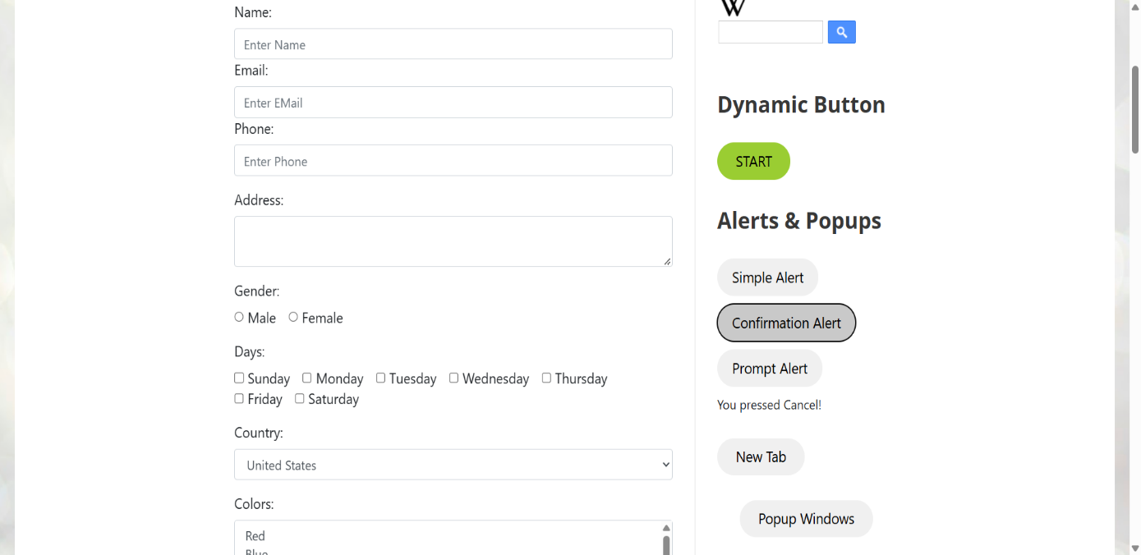
[ Insert Screenshot 2 here ]
assignment_4_step2_confirm_box.png
Figure 2: State after dismissing the Confirmation Box

3.4 Task 3 – Prompt Box (Send Keys & Accept)
# =============================================================
# TASK 3: PROMPT BOX (SEND KEYS & ACCEPT)
# =============================================================
prompt_btn = driver.find_element(By.XPATH, "//button[text()='Prompt Alert']")
prompt_btn.click()
time.sleep(1)

# Switch to Prompt Box, Input Text, and Accept
prompt_alert = wait.until(EC.alert_is_present())
print("Prompt Box Text:", prompt_alert.text)
prompt_alert.send_keys("Riya Maiti")
time.sleep(1)
prompt_alert.accept()
print("Task 3 Completed: Text sent to Prompt Box and accepted.")

time.sleep(1)
driver.save_screenshot("assignment_4_step3_prompt_box.png")
print("Saved: assignment_4_step3_prompt_box.png")

driver.quit()

[ Insert Screenshot 3 here ]
assignment_4_step3_prompt_box.png
Figure 3: Page label reflecting the prompt input submission
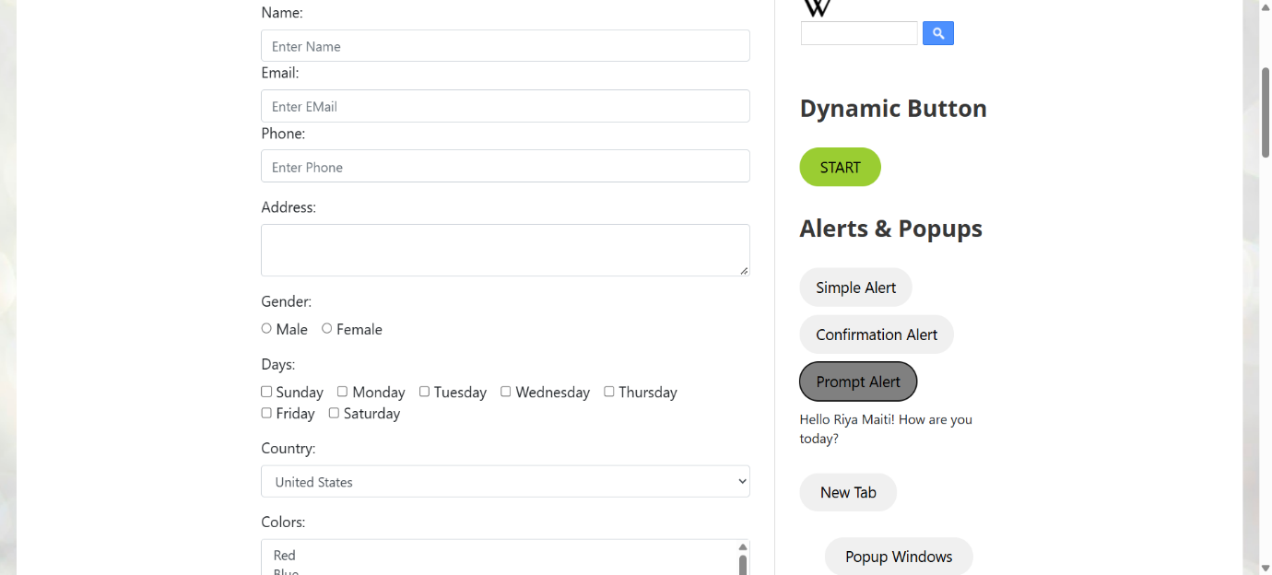
4. Execution & Verification Steps
- Environment Setup: Execute python assignment_4_alerts.py inside the active virtual environment.
Terminal Output Verification:
- Simple Alert Text: I am a simple alert! — Accepted successfully.
- Confirm Box Text: Press a button! — Dismissed (Cancel selected) successfully.
- Prompt Box Text: Please enter your name: — Typed "Riya Maiti" and submitted successfully.
Screenshot Proof Output:
- assignment_4_step1_simple_alert.png — State after accepting Simple Alert.
- assignment_4_step2_confirm_box.png — State after dismissing Confirmation Box.
- assignment_4_step3_prompt_box.png — State showing updated page label reflecting prompt input submission.

5. Conclusion
Assignment 4 from Tier 2 was successfully implemented and verified. All three native JavaScript modal behaviors—accepting alerts, dismissing confirms, and sending text to prompt inputs—were handled cleanly using Selenium WebDriver's Alert interface.

